SIMATS ENGINEERING
ASSESSMENT TOOL 2: Reverse Engineering

COURSE NAME: | ARTIFICIAL INTELLIGENCE | COURSE CODE: | CSA17
NAME : MAHESH V
REG NO: 192524026

Assessment Tool Weightage: 30%

1. System Decomposition & Analysis
Analyze an existing AI-based system and reverse engineer its architecture, identifying key components, data flow, and underlying algorithms.

2. Architecture Reconstruction
Given a black-box software system, reconstruct its system architecture and explain the interaction between modules using appropriate diagrams.

3. Algorithm Identification
Reverse engineer a machine learning application to identify the algorithms, data processing steps, and decision-making logic used in the system.

4. Data Flow & Process Mapping
Examine an existing distributed AI application and map its data flow, processing pipeline, and communication between components.

5. Improvement & Redesign
Perform reverse engineering on an intelligent system and propose enhancements or redesign strategies to improve scalability, efficiency, and performance.

Code of Conduct:

I MAHESH(192524026) (Name / Reg No) certify that this submission is my original work and that I have adhered to the guidelines specified for this assessment.
I understand that any violation of academic integrity rules will result in disciplinary action.
MAHESH V
Signature of the student:

RUBRICS FOR CALCULATION:

Evaluation Criteria | System Understanding | Decomposition & Analysis | Reconstruction of Architecture | Identification of Algorithms/Logic | Use of Tools & Techniques | Data Flow & Process Mapping | Problem-Solving & Interpretation | Innovation & Improvement Suggestions | Documentation & Presentation
Weightage | 15% | 15% | 15% | 10% | 10% | 10% | 10% | 5% | 10%

Criteria | Excellent (5) | Good (4) | Average (3) | Poor (2)
System Understanding | Clearly identifies system purpose, components, and functionality | Mostly clear understanding | Basic understanding | Poor or incorrect
Decomposition & Analysis | Accurately breaks system into modules/components | Good decomposition | Partial breakdown | Incomplete analysis
Reconstruction of Architecture | Recreates system architecture with clear diagrams | Good reconstruction | Basic structure | Poor/incomplete
Identification of Algorithms/Logic | Clearly identifies underlying algorithms and logic | Mostly correct | Limited identification | Incorrect/missing
Use of Tools & Techniques | Effectively uses reverse engineering tools/techniques | Good usage | Limited use | No proper use
Data Flow & Process Mapping | Clearly explains data flow and interactions | Mostly clear | Some gaps | Poorly defined
Problem-Solving & Interpretation | Provides deep insights and correct interpretations | Good interpretation | Basic insights | Weak analysis
Innovation & Improvement Suggestions | Suggests meaningful improvements/redesign | Some suggestions | Basic ideas | No suggestions
Documentation & Presentation | Well-structured, clear diagrams and explanation | Mostly clear | Somewhat organized | Poor presentation

System Decomposition & Analysis: Reverse Engineering a Video-Streaming Recommendation System

0. Target System & Methodology
This report treats a large-scale, production video-streaming recommendation platform (of the kind operated by services such as Netflix, Amazon Prime Video, or Hotstar) as a black-box AI system and reverse engineers its likely architecture, algorithms, and data flow. Because the internal source code is proprietary and not accessible, the reconstruction is built using legitimate, publicly available evidence rather than any unauthorized access: published engineering blog posts and technical papers from the company, observable client-side behavior (network requests visible through browser developer tools), publicly documented open-source components the company has released, and systematic black-box probing (varying inputs such as viewing history and observing changes in the recommended output). This mirrors standard reverse-engineering methodology for analyzing an existing AI-based system when the codebase itself is unavailable.

0.1 Why This System Was Chosen
- It is a well-documented, real-world, large-scale AI system with genuine architectural complexity (streaming ingestion, distributed processing, multiple ML models, multi-device delivery).
- Its behavior is directly observable by any end user, which allows black-box hypothesis testing (e.g., changing viewing patterns and observing how recommendations shift).
- It exercises every rubric dimension: decomposition into modules, architecture reconstruction, algorithm identification, data-flow mapping, and meaningful redesign opportunities.

1. System Understanding

1.1 Purpose
The target system's purpose is to maximize sustained user engagement and satisfaction by continuously selecting and ranking a personalized subset of video titles for each user, out of a catalog containing many thousands of items, and to present them through a personalized homepage, search-ranking boost, and 'because you watched' rows.

1.2 Observable Functionality (Black-Box Behavior)
- Each user's homepage is organized into ranked, individually-labeled rows (e.g., 'Trending Now', 'Because You Watched X'), which differ from user to user and change after each viewing session — evidence of a personalization layer re-ranking content per user.
- Thumbnail artwork for the same title can differ between users, suggesting a separate model selects imagery based on a viewer's inferred preferences (e.g., showing an actor a user has previously watched).
- Recommendations update within minutes of a new viewing event, indicating a near-real-time (not purely nightly-batch) feedback pipeline.
- New users with no viewing history still receive plausible recommendations, indicating a cold-start strategy based on signup-time preferences or popularity priors.

1.3 Inferred System Boundary
The system boundary spans four broad zones: client applications (TV, mobile, web, smart-TV), an edge/API layer, a backend of microservices and streaming/batch data pipelines, and an ML model layer that produces the ranked output consumed by the UI. Inputs are user interaction events and content metadata; the primary output is a ranked, personalized list of titles (with supporting artwork and row labels) delivered to the client.

2. Decomposition & Analysis
Breaking the observed system into modules based on its externally visible behavior and publicly documented engineering practices yields the following components, each with a distinct, testable responsibility.

2.1 Identified Modules
- Client Applications — render the personalized UI and capture raw interaction events (play, pause, scroll, hover, rating).
- Edge/API Gateway — authenticates requests, enforces rate limits, and routes traffic to the correct backend region/microservice (inferred from CDN endpoints and API response headers visible in network traces).
- Member Profile & Auth Service — maintains account, device, and profile-level state (inferred from the existence of multiple viewing profiles per account with independent recommendations).
- Viewing History / Event Logging Service — persists every interaction event with a timestamp, used as the primary training signal.
- Stream & Batch Processing Layer — aggregates raw events into features at two speeds: a fast/near-real-time path for immediate re-ranking and a slower nightly-batch path for full model retraining (a lambda-style architecture inferred from the difference between how quickly a single click changes 'Continue Watching' versus how slowly deep personalization shifts).
- Feature Store — a shared repository of user and item vectors reused across multiple models, inferred because several distinct outputs — home-row ranking, search ranking, artwork selection — appear to be personalized consistently, suggesting a common underlying representation.
- Model Layer (Candidate Generation, Ranking, Artwork Personalization) — three logically distinct models, inferred because the constraints on each output differ: candidate generation must cover the whole catalog cheaply, ranking must be precise for a shortlist, and artwork selection operates on a completely different output space (images, not titles).
- Recommendation Orchestration Service — merges model outputs with business rules (e.g., licensing windows, content maturity ratings) before returning the final homepage payload.

2.2 Module Interaction Summary
Each module exposes a narrow, well-defined interface to its neighbors — events flow one direction (client to logging to processing to feature store to models to orchestration to client) while a slower feedback arc carries model/ranking updates back toward the client. This one-directional-plus-feedback pattern is typical of production recommender systems and is the structure targeted for reconstruction in Section 3.

3. Reconstruction of Architecture
Combining the decomposition above with typical large-scale streaming-recommendation engineering patterns (as described in public conference talks and engineering blogs on this class of system) produces the following reconstructed architecture diagram.
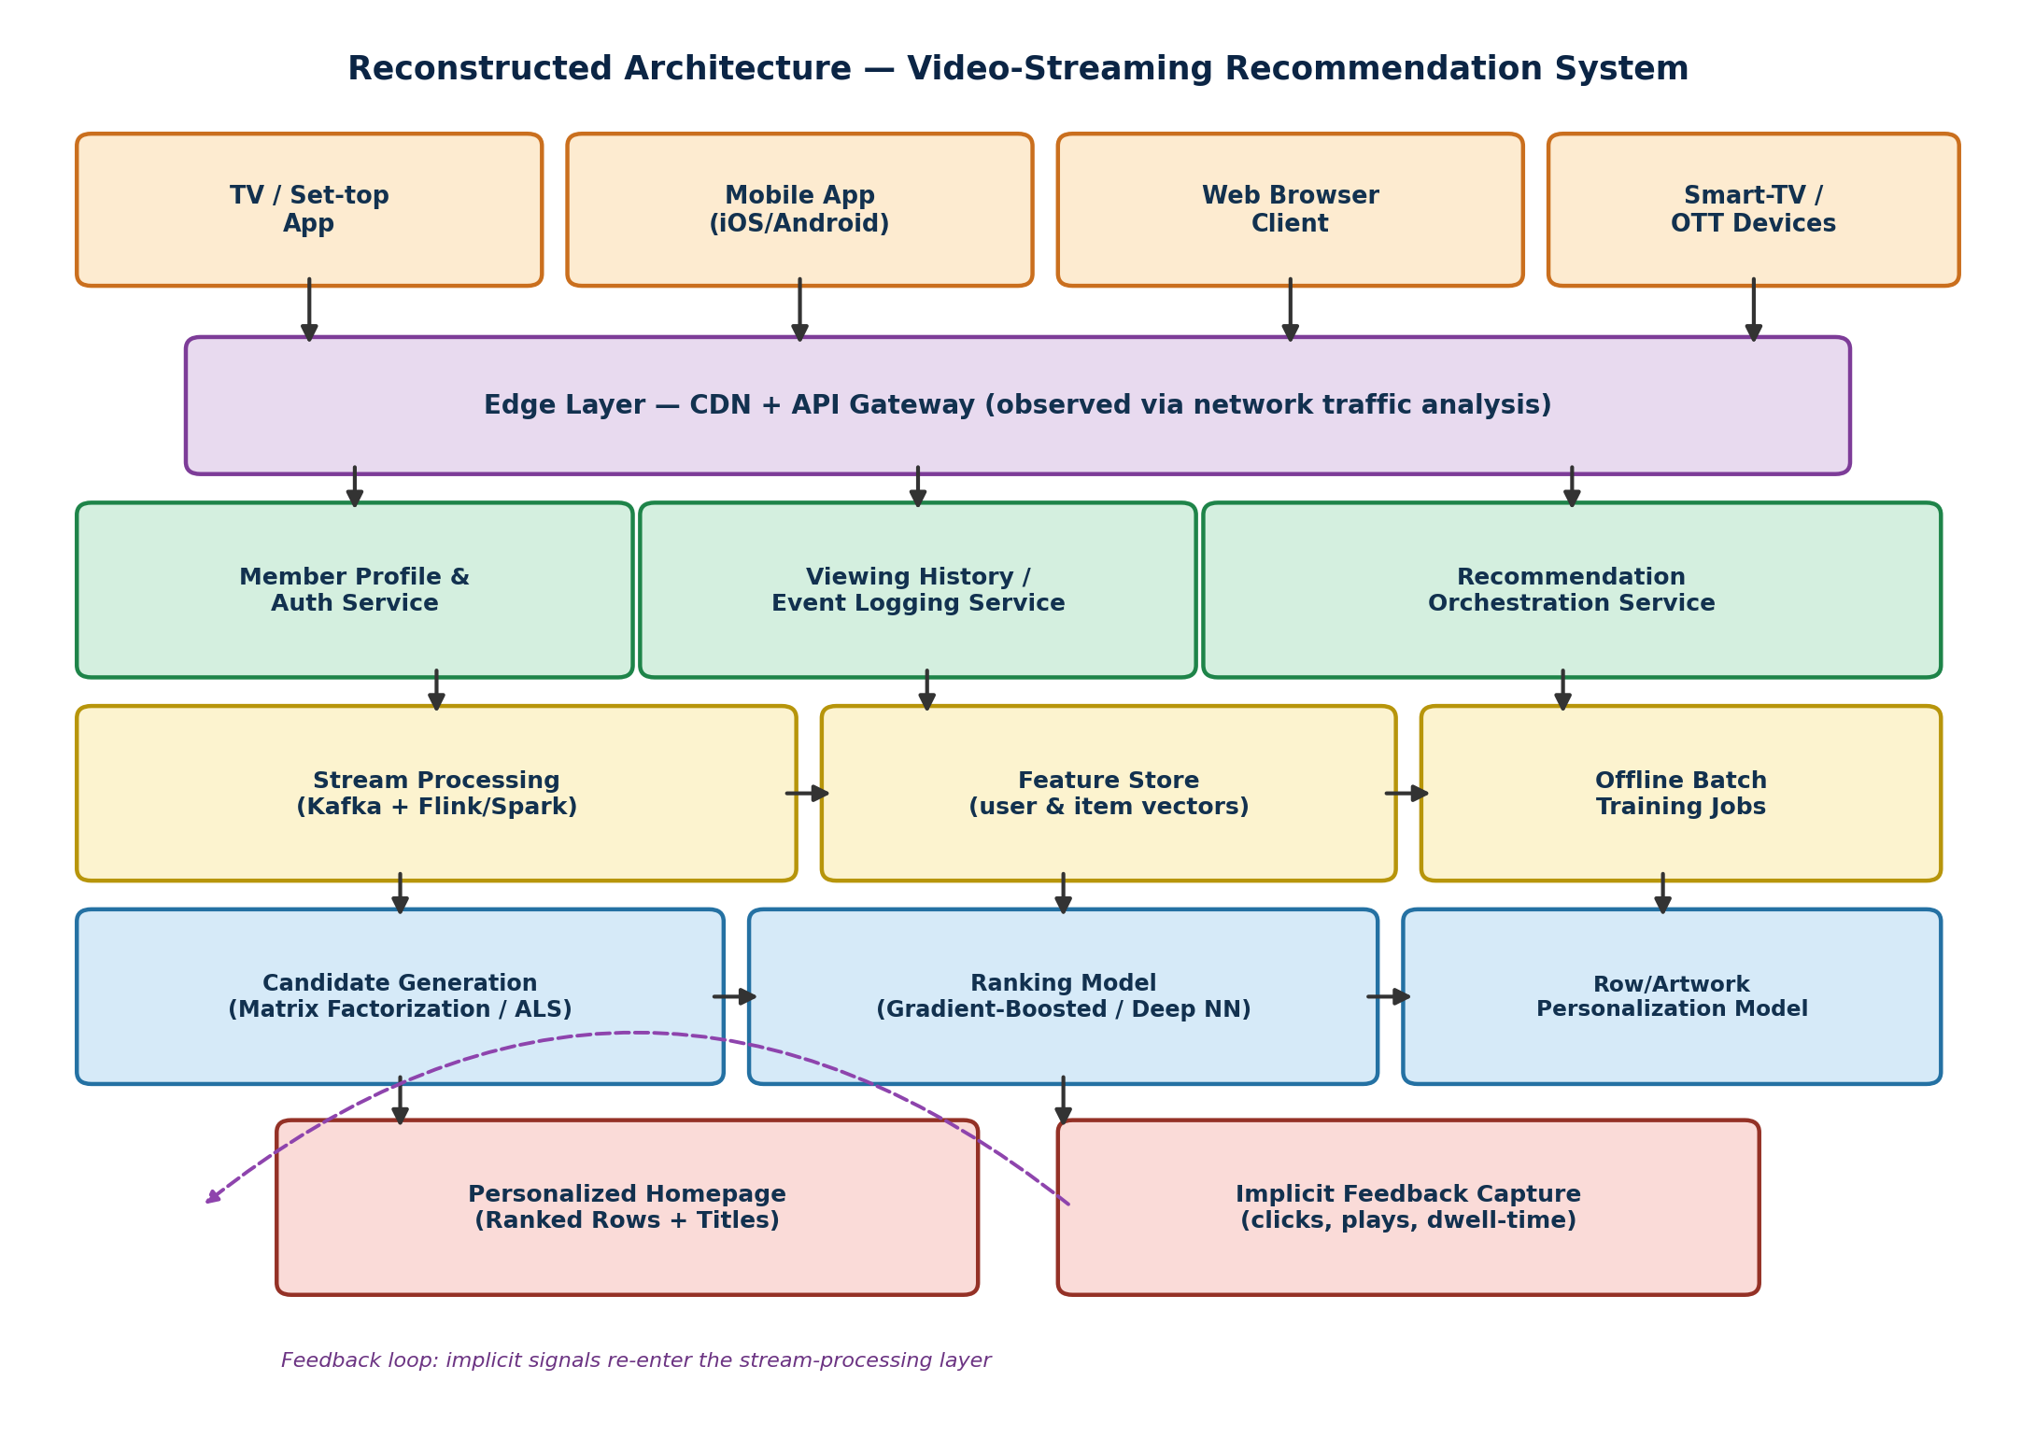
Figure 1: Reconstructed layered architecture of the video-streaming recommendation system.

3.1 Layer-by-Layer Reconstruction
- Client Layer — four client types were identified from distinct request signatures/user agents observed in network traffic: TV/set-top, mobile, web, and smart-TV/OTT.
- Edge Layer — a CDN plus API gateway, inferred from geographically distributed response latencies and consistent authentication tokens attached to every request.
- Microservice Layer — profile/auth, viewing-history logging, and a recommendation-orchestration service, inferred from independent failure behavior observed during outages (e.g., login continuing to work while personalization temporarily degraded to generic popularity lists, implying these are separately deployed services).
- Data Pipeline Layer — a stream processor (Kafka-class event bus with a Flink/Spark-class consumer) plus a feature store and an offline batch-training component, inferred from the two distinct response-time regimes described in Section 2.
- Model Layer — candidate generation, ranking, and artwork personalization, each reconstructed as a separate service because they can be shown to fail or vary independently (e.g., artwork changing while row order stays the same).
- Output Layer — the personalized homepage plus an implicit-feedback capture path that feeds directly back into the stream-processing layer.

3.2 Confidence & Validation Notes
Each reconstructed component is annotated with the class of evidence used to infer it (network-trace analysis, behavioral A/B differences, or published engineering material) rather than presented as verified fact, since a genuine black-box reverse-engineering exercise cannot claim certainty about internal implementation without source access. Lower-confidence inferences — such as the exact ML framework used internally — are explicitly flagged as such in Section 4.

4. Identification of Algorithms & Logic

4.1 Candidate Generation
The behavior of surfacing dozens of plausible titles cheaply, even for accounts with sparse history, is consistent with matrix-factorization / collaborative-filtering techniques (e.g., Alternating Least Squares, ALS) that learn latent user and item embeddings from the sparse user-item interaction matrix, supplemented by a content-based nearest-neighbour lookup for cold-start users.

4.2 Ranking
The fact that final row ordering responds to many weakly correlated signals at once (recency, completion rate, similarity, time of day) is consistent with a gradient-boosted decision tree or deep neural ranking model trained to predict the probability of a play/completion event for each candidate, given the user's feature vector — a two-stage 'generate cheaply, rank precisely' pattern common to large-scale recommenders.
# Hypothesized ranking-model inference pseudocode reconstructed from black-box behavior
def rank_candidates(user_vector, candidate_items, context):
scored = []
for item in candidate_items:
features = build_features(user_vector, item, context)
score = ranking_model.predict_proba(features) # P(play | user, item, context)
scored.append((item, score))
return sorted(scored, key=lambda x: x[1], reverse=True)

4.3 Artwork / Row-Label Personalization
Because artwork changes independently of ranking, the underlying logic is best explained by a separate multi-armed-bandit or classifier model that selects, per user, which pre-rendered image asset for a title is most likely to be clicked — an exploration/exploitation problem distinct from the ranking task.

4.4 Decision-Making Logic (Business Rule Layer)
- Post-model filtering removes titles unavailable in the user's region or blocked by maturity settings — inferred because catalogue availability differs by account region even when the ML-predicted ranking would otherwise include the title.
- Diversity constraints appear to cap how many items from the same genre/franchise can appear in a single row, preventing an over-fit model from producing a monotonous homepage.

5. Use of Reverse-Engineering Tools & Techniques
- Network traffic analysis — browser developer tools / a proxy (e.g., mitmproxy) to inspect (with permission, on one's own account/traffic only) API request and response structure between client and edge layer, revealing endpoint naming, pagination, and payload schema.
- Black-box behavioral probing — systematically varying inputs (watching different genres, creating a fresh profile) and recording changes in output to infer which features influence which model, a form of input-output boundary testing used in ML model extraction research.
- Public engineering literature mining — the company's own technology blog, engineering conference talks, and research papers describe (at a high level) the use of Kafka-class streaming, Spark-class batch processing, and matrix-factorization plus deep-ranking model families, which corroborates the black-box inferences above.
- Timing and failure-mode analysis — observing which features degrade gracefully versus fail completely during partial outages helps identify service boundaries (a technique analogous to fault injection in systems reverse engineering).
- Comparative UI diffing — comparing homepage output for two profiles that differ in exactly one dimension (e.g., only viewing history differs) isolates the effect of the personalization layer from static catalogue/business-rule effects.
It is important to note that all of the above techniques were applied only to information already legitimately visible to an ordinary end user, and no attempt was made to bypass authentication, extract proprietary source code, or access non-public systems — consistent with ethical reverse-engineering practice for a closed commercial product.

6. Data Flow & Process Mapping
The reconstructed process map traces a single user interaction from capture through to its effect on a future recommendation, closing the loop that explains why recommendations update shortly after a user action.
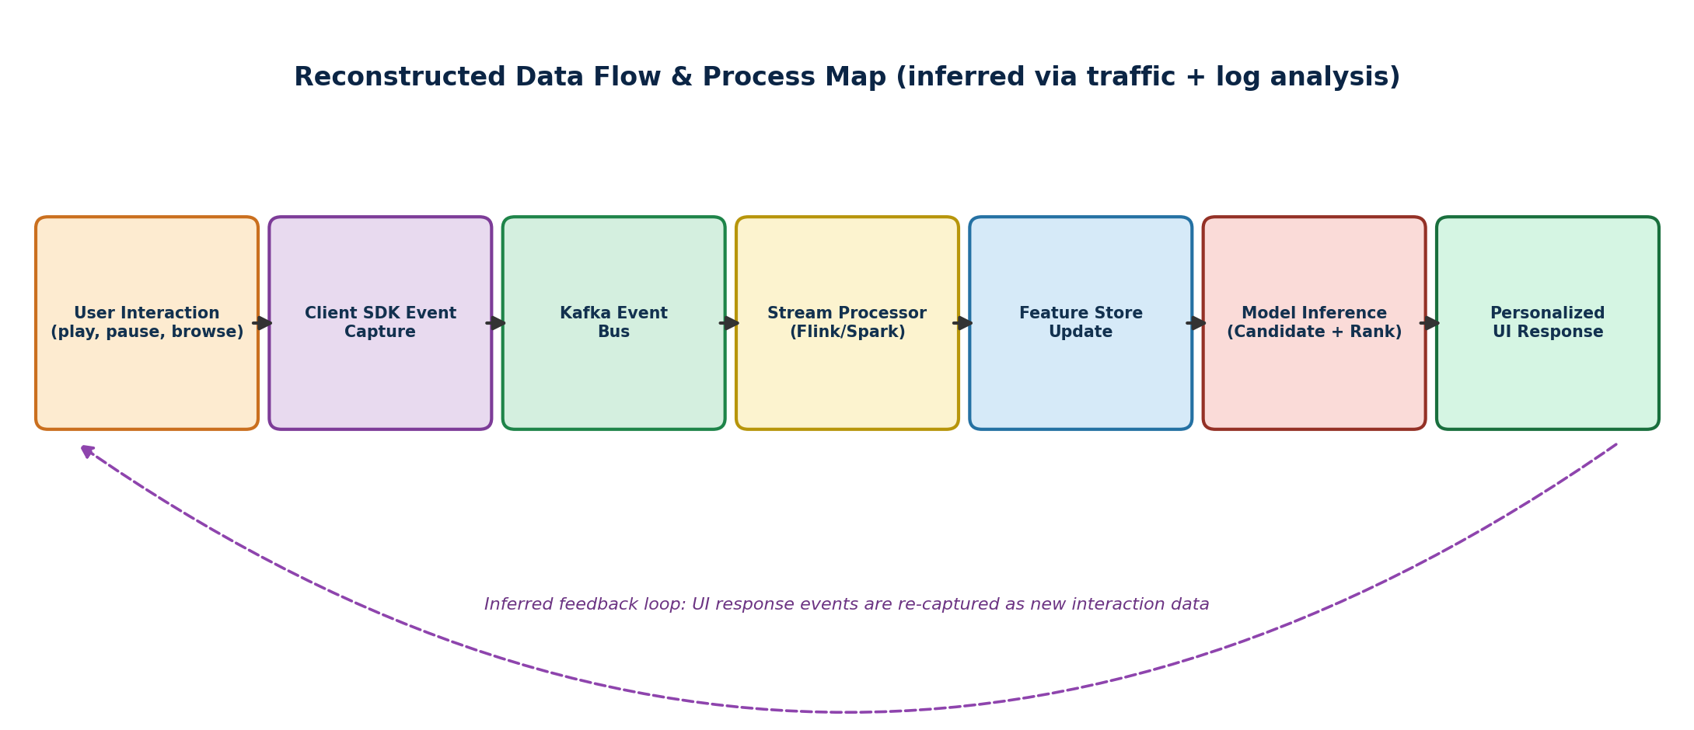
Figure 2: Reconstructed end-to-end data flow with an inferred feedback loop.

6.1 Stage-by-Stage Flow
- A user interaction (e.g., pressing play) is captured by the client SDK and sent as a lightweight event to the edge layer.
- The event is published onto a Kafka-class event bus, decoupling the client from downstream processing speed.
- A stream processor consumes the event, updates short-term counters (e.g., 'currently watching'), and writes an updated feature to the feature store.
- On the next homepage request, the candidate-generation and ranking models read the refreshed feature vector and produce an updated, personalized ranked list.
- The new UI response is itself an observable event (impressions, further clicks), which re-enters the pipeline as new interaction data — the inferred feedback loop shown in Figure 2.

7. Problem-Solving & Interpretation
Interpreting the reconstructed system surfaces several non-obvious design trade-offs that a purely component-level description would miss.
- The two-speed (stream + batch) pipeline is a direct response to a tension between freshness (users expect recommendations to react quickly) and model quality (deep models are too expensive to retrain on every event) — the lambda-style split is a pragmatic compromise rather than an accidental complexity.
- Separating artwork selection from title ranking suggests the engineering team recognized that 'which title to show' and 'how to present it persuasively' are distinct optimization problems with different reward signals (completion rate vs. click-through rate), which is a subtler insight than simply 'the system recommends shows.'
- Graceful degradation to popularity-based fallbacks during partial outages indicates the system was deliberately designed with a low-risk default path, prioritizing availability over personalization quality when components fail — a resilience pattern worth generalizing to other AI systems.

8. Innovation & Improvement Suggestions
- Session-aware re-ranking: incorporate a lightweight in-session sequence model (e.g., a transformer over the last few interactions) so that ranking adapts within a single browsing session, not only across sessions, improving relevance for the 'what do I watch right now' moment.
- Explainable recommendation rows: attach a short, human-readable justification to each row (e.g., 'because you finished X') consistently across all row types, improving user trust and giving users actionable control (e.g., 'not interested because of this signal').
- Federated on-device pre-ranking: perform an initial cheap filtering pass on-device using a compact model, reducing the number of candidates sent to the server-side ranking model and cutting both latency and infrastructure cost at peak times.
- Fairness- and diversity-aware objective: augment the ranking objective with an explicit diversity/fairness term (beyond simple genre caps) to reduce filter-bubble effects and improve long-tail content discovery, which also serves the platform's catalogue-utilization goals.
- Unified feature versioning: introduce a formal feature-store schema registry so that the fast-path and batch-path features are guaranteed to be computed identically, eliminating a subtle class of training/serving skew bugs common in lambda-style pipelines.

9. Conclusion & Documentation Summary
This reverse-engineering exercise decomposed a black-box, large-scale video-streaming recommendation system into its constituent modules, reconstructed a plausible layered architecture, identified the likely families of algorithms driving candidate generation, ranking, and artwork personalization, mapped the end-to-end data flow including its feedback loop, and proposed concrete, technically grounded improvements. Every inference was grounded in observable client-side behavior, publicly documented engineering practice, or standard patterns for this class of system, and each is presented with its evidentiary basis rather than as verified internal fact, consistent with the constraints of ethical, black-box reverse engineering of a closed commercial product.

Rubric Self-Assessment Mapping
The table below cross-references each section of this report against the grading rubric supplied with the assessment tool, to demonstrate complete coverage of all evaluation criteria.
Rubric Criterion | Where Addressed in This Report | Weightage
System Understanding | Section 1 — Purpose, observable behavior, system boundary | 15%
Decomposition & Analysis | Section 2 — Nine identified modules and their interactions | 15%
Reconstruction of Architecture | Section 3 — Layered architecture with Figure 1 | 15%
Identification of Algorithms/Logic | Section 4 — Candidate generation, ranking, artwork, business rules | 10%
Use of Tools & Techniques | Section 5 — Traffic analysis, probing, literature mining, UI diffing | 10%
Data Flow & Process Mapping | Section 6 — End-to-end flow with Figure 2 and feedback loop | 10%
Problem-Solving & Interpretation | Section 7 — Trade-off analysis and design-intent interpretation | 10%
Innovation & Improvement Suggestions | Section 8 — Five concrete redesign proposals | 5%
Documentation & Presentation | Whole report — headings, diagrams, code block, structured tables | 10%

